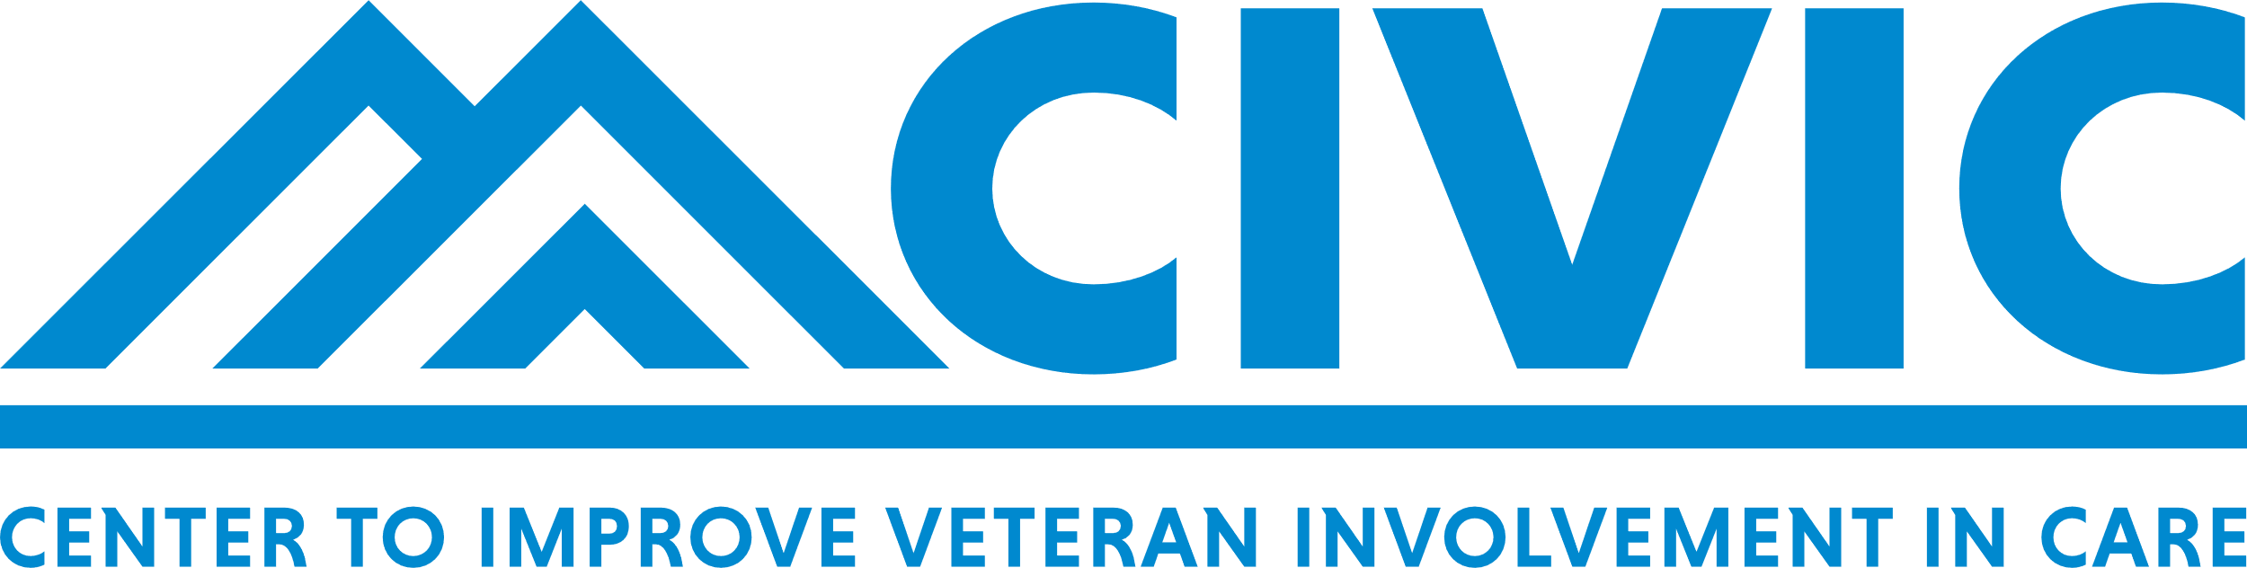

Center to Improve Veteran Involvement in Care (CIVIC)
VA Health Systems Research Center of Innovation
September 24, 2024

Leadership:
Steven Dobscha, MD – Center Director
Lauren Denneson, PhD – Associate Director
Avery Laliberte, BA – Administrative Officer
Background: The mission of the Center to Improve Veteran Involvement in Care (CIVIC) is to support high quality research on patient-centered approaches that promote Veteran engagement and active participation in VA and non-VA healthcare and other resources to improve Veteran health and well-being.
Significance: Patient involvement in care improves clinical outcomes, and patient-centered communication, collaboration, and coordination within and across care teams are critical elements to optimizing patient involvement in care. CIVIC’s updated mission specifically supports several VHA 2022-2028 strategic objectives including 1) the delivery of timely, accessible, high-quality benefits, care and services to meet the needs of underserved, marginalized and at-risk Veterans to prevent suicide and homelessness, improve their economic security, health, resiliency and quality of life and achieve equity (Strategic Objective 2.1); 2) VA and its partners will tailor the delivery of benefits and customize whole health care and services for the recipient at each phase of their life journey (Strategic Objective 2.2); and 3) VA, with community partners, will deliver integrated care and services, balancing resources to ensure sustainability while continuing to deliver value and improve health and well-being outcomes of Veterans (Strategic Objective 2.5).
Impact Goals and Priorities: CIVIC’s first impact goal is to develop and implement interventions and other approaches that improve the healthcare, health, and safety of Veterans who have elevated suicide risk and mental health conditions including pain. This goal leverages our current research and methodologic strengths across seven areas of innovation including firearms safety, technology and social media, engaging family, supports and community, risk and health trajectories in Veteran sub-populations, pain treatment interventions including whole health, opioid use/discontinuation and treatment of opioid use disorder, and evidence science. Our second impact goal is to develop innovative strategies that increase access and improve care coordination within VHA and across VHA and community settings. This goal builds on our current research activities and expertise across three areas of innovation: Access/care coordination within VHA, access/care coordination spanning VHA and the community, and cancer and palliative care processes and outcomes.
Additional Contribution Areas include 1) sleep medicine and improving and implementing clinical pathways for diagnosis and treatment of sleep apnea; and 2) implementing evidence-based practices, policies, and programs to target the improved use of antibiotics and the prevention of health care-associated infections.
Innovation and Emerging Areas include 1) development of interventions to sustain the workforce and minimize burnout; 2) understanding and disseminating information about risks, benefits and impacts of cannabis use; and 3) understanding, developing treatments, and providing guidance to clinicians regarding Long-COVID.
Partnership & Support for Research Enterprise: CIVIC’s active partners are VA’s Office of Suicide Prevention (formerly Office of Mental Health & Suicide Prevention); VA Office of Rural Health; VA Pain Management, Opioid Safety and PDMP; VA Office of Patient Centered Care and Cultural Transformation; VA Office of Integrated Health Care; VA Office of Nursing Services; VA Office of Care Management and Social Work; VA Geriatrics and Extended Care; VA Primary Care, VISN 20, VA Portland Health Care System, and Oregon Health & Science University. CIVIC investigators support the national research enterprise through 1) the VA Evidence Synthesis Program National Coordinating Center (Dr. Mackey); 2) development and curation of the national PTSD Repository and Suicide Prevention Trials Database (Drs. O’Neil and Denneson); 3) leadership of two HSR Consortia of Research (CORES), the Suicide Prevention Research Impact Network (SPRINT) (Dr. Dobscha is HSR Corresponding PI) and the Access and Community Care Engagement Network Team (ACCENT) (Dr. Hynes); and 4) the Veterans Rural Health Resource Center—Portland (Drs Lovejoy and Ono).

